Assignment-32.3:

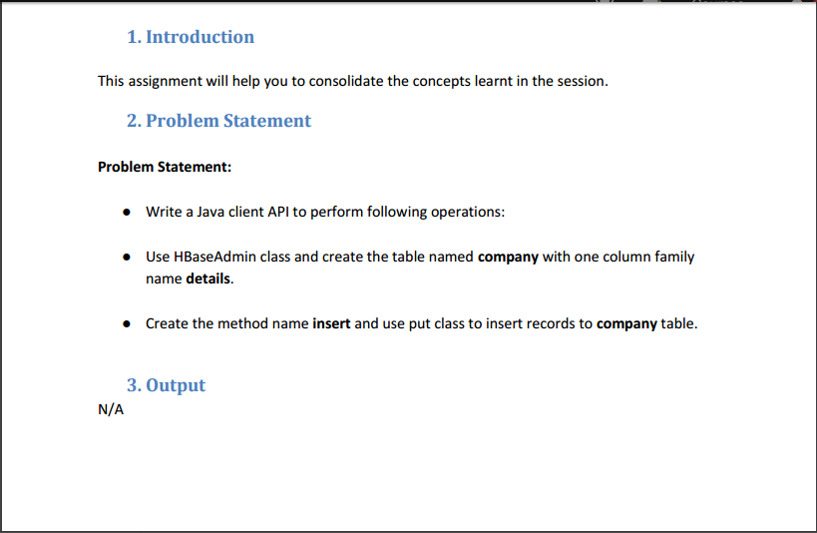

In the question we are told to create a table named ‘Company’ but I’m creating a table named ‘Employee’. The Java program to create a HBase table is presented below

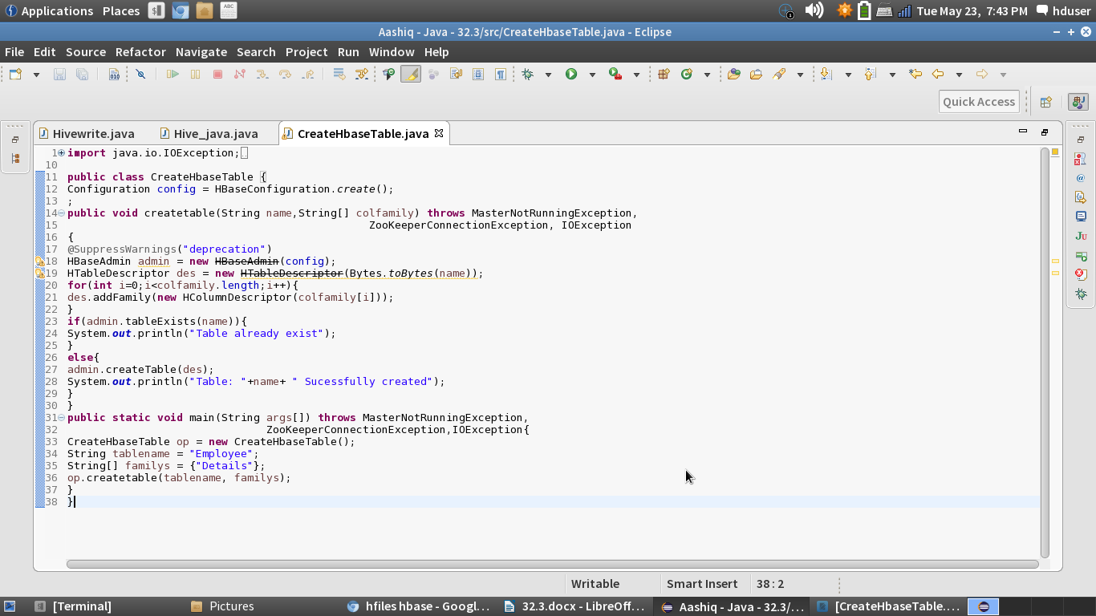

The above program will create an empty table named ‘Employee’, we can check the same in the HBase.

Console:

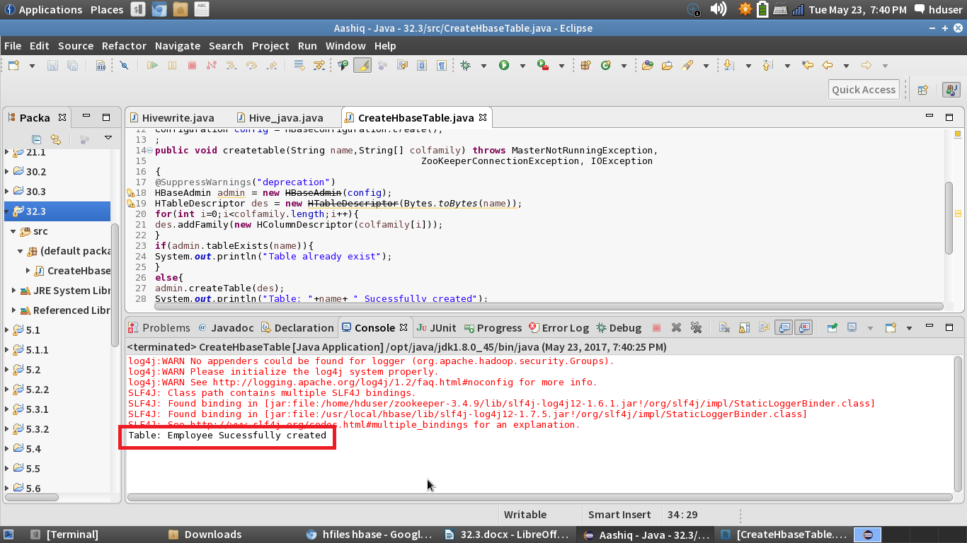

In the HBase, an empty table named ‘Employee’ is created.

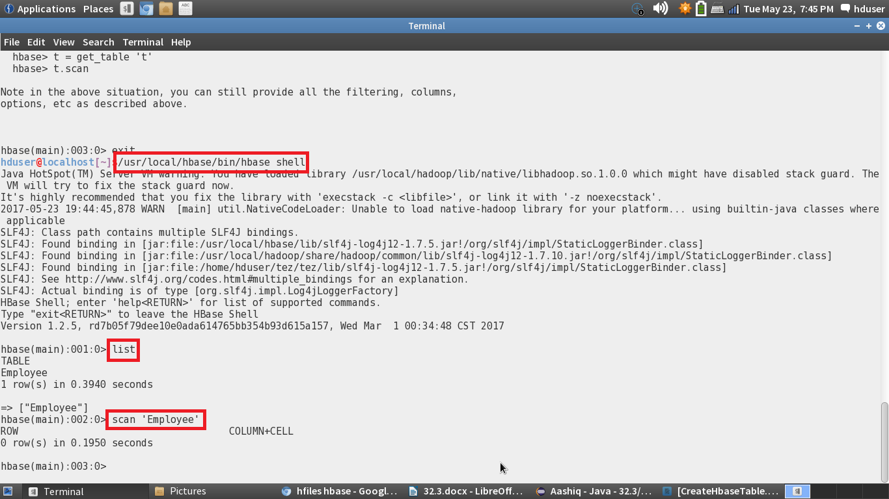

Java program to insert the values into the Employee table:

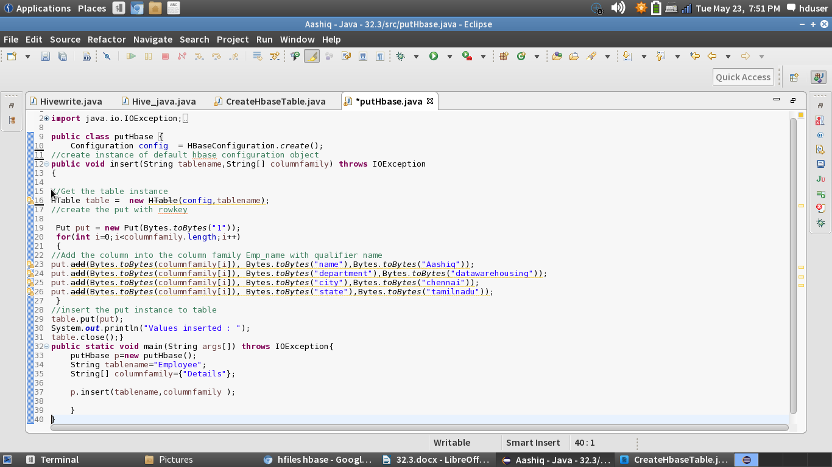

Console:

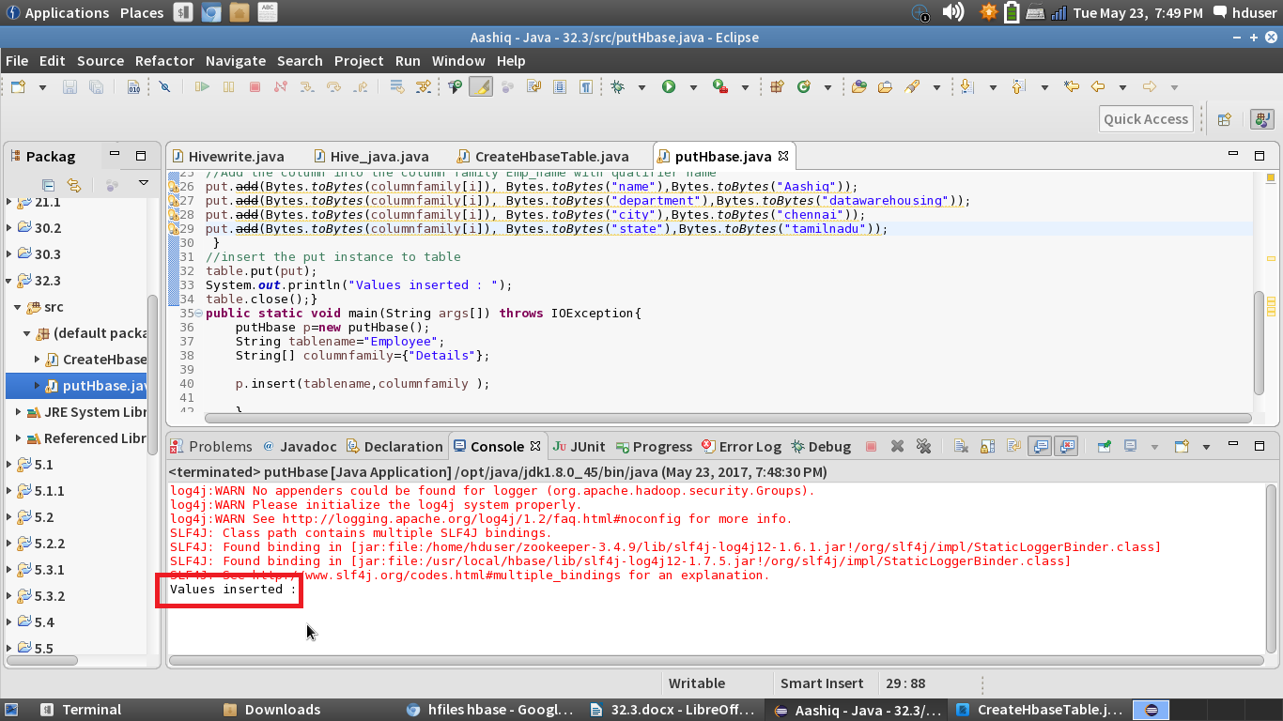

Checking whether the values are inserted in HBase using scan command:

